24th January 2020

Precise temperature monitoring in systems and piping with new temperature sensor in the GEMÜ range

The new GEMÜ 3240 temperature transducer/switch now allows precise temperature monitoring in systems and piping across an even broader measuring range.

The GEMÜ 3240 temperature transducer/switch supersedes the existing GEMÜ 3220 product range with immediate effect. The new sensor's high-quality measuring cells are able to withstand media temperatures of between -40 °C and +150 °C and operating pressures of up to 160 bar while maintaining an accuracy of 0.35% FSO.
In addition to the considerably broader measuring scope, the new series scores highly in terms of its wide range of features. For demanding acid/alkali applications, all media wetted parts are available with PVDF encapsulation, for example.

IO-Link for intelligent networking
With an IO-Link interface, the GEMÜ 3240 temperature transducer/switch can be used centrally to automate and monitor processes. This is beneficial for system networking, for example, as it makes components compatible with one another and facilitates parameterization and data transmission.
The rotatable LED display is another advantage: The 4-digit display allows the current operating parameters to be viewed in any installation position.

Versatility
The new GEMÜ 3240 temperature transducer/switch can be used for a wide variety of applications. The sensor is a reliable temperature measurement and control instrument for use in cooling circuits or for monitoring sterilization processes. It is suitable for a huge variety of media, such as highly viscous or contaminated media. In addition, the high-quality material from which the sensor is made means that it is able to withstand even chemically corrosive media.

With its 3140-series pressure transducer/switch, which it launched back in 2018, GEMÜ has already been able to boast state-of-the-art measurement systems for measuring and controlling pressure. This device is now joined by the new temperature sensor, which broadens the scope of the measurement and control systems range.
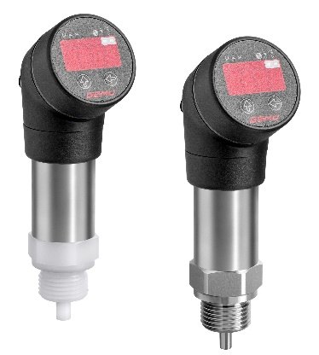
Temperature sensor GEMÜ 3240 with various process connections of metal and plastics

Background information

The GEMÜ Group develops and manufactures valves, measurement and control systems for liquids, vapours and gases. GEMÜ is a global market leader when it comes to solutions for sterile applications.

The globally focused, independent family-owned enterprise was founded in 1964. In 2011, Gert Müller took over as Managing Partner together with his cousin Stephan Müller, becoming the second generation to run the company.

The Group achieved a turnover of over €330 million in 2019 and currently employs over 1900 members of staff worldwide, over 1100 of whom are in Germany. They have six manufacturing locations: Germany, Switzerland and France, as well as China, Brazil and the USA. Their worldwide marketing is carried out across 27 subsidiaries, coordinated from Germany. Thanks to a large network of commercial partners, GEMÜ is now active in over 50 countries on all continents.

Please visit www.gemu-group.com for further information.

