3rd February 2022

Valve automation for modern plant control systems

GEMÜ introduces new electrical position indicators and combi switchboxes

Valve manufacturer GEMÜ is expanding its product range for automation components in the processing industry. The new electrical position indicators GEMÜ 1240, 1241 and 1242 and the combi switchboxes GEMÜ 4240, 4241 and 4242 will ensure reliable recording of valve end positions and form the basis for successful process automation – even in potentially explosive areas.

An integrated sensor on the GEMÜ electrical position indicators and combi switchboxes records the end position of the process valves and transmits it to the plant control system with a signal. With combi switchboxes, the process valve can also be actuated with the integrated pilot valve. The process valve and automation components are optimally adapted to each other. The entire system is preset and tested, saving users time and effort for logistics, installation and documentation. The new electrical position indicators and combi switchboxes can be combined with single-acting or double-acting linear actuators or quarter turn actuators and are therefore suitable for diaphragm, globe and diaphragm globe valves as well as for ball valves and butterfly valves. Users can benefit from designs with simple proximity switches or microswitches, but GEMÜ also offers programmable solutions with 24 V, AS-Interface, DeviceNet and IO-Link interfaces for modern process automation.

Designs with ATEX, IECex or NEC approvals are available for potentially explosive areas. As a result, users can achieve reliable monitoring of the installed valves, especially for plants with strict safety or quality requirements. GEMÜ also supports customers during the automation of their plants in external process environments.

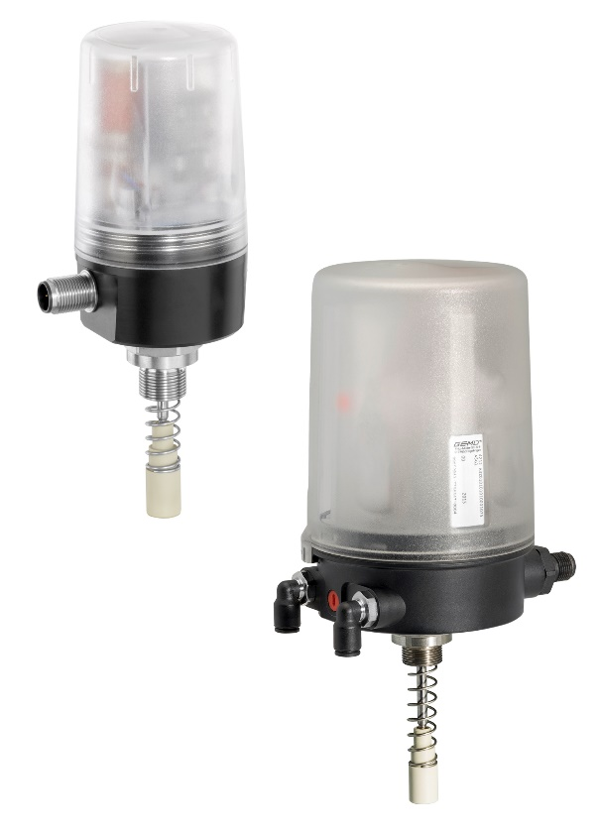
Electrical position indicator GEMÜ 1242 und combi switchbox GEMÜ 4242

About us

The GEMÜ Group develops and manufactures valves, measurement and control systems for liquids, vapours and gases. GEMÜ is a global market leader when it comes to solutions for sterile applications.
The globally focused, independent family-owned enterprise was founded in 1964. In 2011, Gert Müller took over as Managing Partner together with his cousin Stephan Müller, becoming the second generation to run the company. The Group achieved a turnover of over €450 million in 2021 and currently employs over 2200 members of staff worldwide, over 1200 of whom are in Germany. They have six manufacturing locations: Germany, Switzerland and France, as well as China, Brazil and the USA. Their worldwide marketing is carried out across 27 subsidiaries, coordinated from Germany. Thanks to a large network of commercial partners, GEMÜ is now active in over 50 countries on all continents.
Please visit www.gemu-group.com for further information.

