5th April 2024

New GEMÜ BB0F ball valve series

The new ball valves in the GEMÜ BB0F series from valve specialists GEMÜ cover a wide range of applications in the chemical industry thanks to their configuration and the available construction and actuator versions.

In the standard version, the media wetted seat seals are made of PTFE with glass-fibre reinforcement (reinforced PTFE). This is what gives them exceptionally high material resistance when exposed to changing media and enables a wide range of applications and a high level of safety when using dangerous media. The stainless steel ball valves are suitable for use in applications at temperatures between -40 °C and 220 °C.
Thanks to its two-piece body, the ball valve has only one connection point, guaranteeing reliable tightness. The ball valve has a fire safe design as standard in accordance with API 607 and DIN EN ISO 10497, with the housing and shaft seal made of graphite.

The risk of fire can exist in all types of production plant, but fire protection measures play an important role in some industrial sectors and processes. In these areas of application, a fire safe valve such as the GEMÜ BB0F is the right choice. The ball valve is available in nominal sizes DN 15 to DN 200 with flanged connections ANSI class 150 and PN40/PN16.

Alongside applications in the chemical industry, this ball valve can also be used for heating systems and HVAC applications.

The new GEMÜ BB0F series includes the GEMÜ B2F manual ball valve, the GEMÜ B4F pneumatic ball valve and the GEMÜ B6F motorized version.

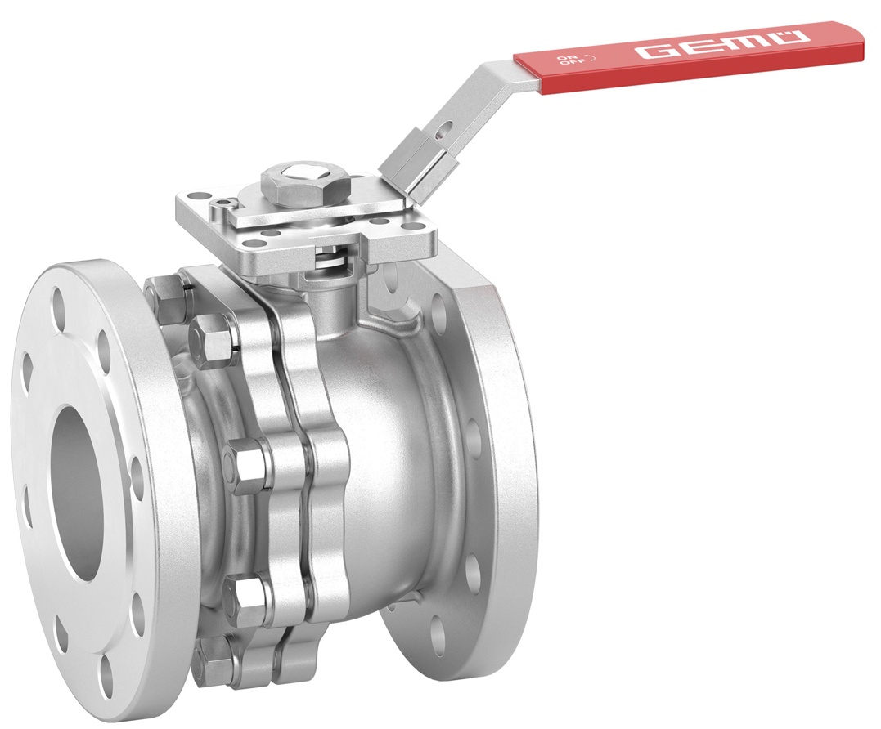

GEMÜ B2F manually operated ball valve from the new GEMÜ BB0F series

About us

The GEMÜ Group develops and manufactures valves, measurement and control systems for liquids, vapours and gases. GEMÜ is a global market leader when it comes to solutions for sterile applications.
The globally focused, independent family-owned enterprise was founded in 1964. In 2011, Gert Müller took over as Managing Partner together with his cousin Stephan Müller, becoming the second generation to run the company. The Group achieved a turnover of over €580 million in 2023 and currently employs over 2500 members of staff worldwide, over 1400 of whom are in Germany. They have six manufacturing locations: Germany, Switzerland and France, as well as China, Brazil and the USA. Their worldwide marketing is carried out across 27 subsidiaries, coordinated from Germany. Thanks to a large network of commercial partners, GEMÜ is now active in over 50 countries on all continents.
Please visit www.gemu-group.com for further information.

