29th May 2024
Reliable quarter turn valves for gas applications

GEMÜ butterfly valves in the GEMÜ R480 Victoria series and the GEMÜ B20 ball valve have been awarded gas approval by DVGW (German Technical and Scientific Association for Gas and Water).

The GEMÜ R480 Victoria and GEMÜ B20 are suitable for use with different gases, such as natural gas and biogas (the main component of which is methane), propane and liquid gases containing butane. They are approved for gas production, treatment and injection. This includes use for combustible gases in gas families two and three in gas burners and gas appliances. It also includes the use of hydrogen. The DVGW regulatory code is used to confirm the ability of these valves to work reliably and precisely in different gas environments.

The butterfly valves are available in nominal sizes DN 25 to DN 600 and can be ordered with the "G" (the marking for gas) special function with immediate effect. The GEMÜ B20 ball valve in nominal sizes DN 8 to DN 65, which also has the "G" special function, is suitable for use with combustible gases. A yellow hand lever is available as an option for better visual identification. A type examination was carried out for both quarter turn valves in accordance with DIN EN 13774.

The GEMÜ R480 Victoria butterfly valve is certified and listed under registration number DG-313CQ0540, and the GEMÜ B20 ball valve under registration number 22-00143-AB01-130.

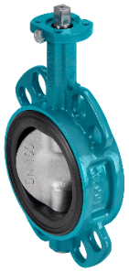
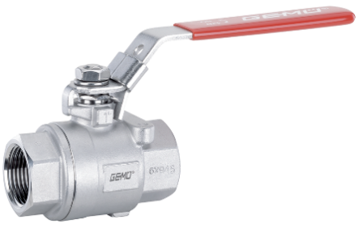

GEMÜ B20 GEMÜ R480 Victoria

About us

The GEMÜ Group develops and manufactures valves, measurement and control systems for liquids, vapours and gases. GEMÜ is a global market leader when it comes to solutions for sterile applications.
The globally focused, independent family-owned enterprise was founded in 1964. In 2011, Gert Müller took over as Managing Partner together with his cousin Stephan Müller, becoming the second generation to run the company. The Group achieved a turnover of over €580 million in 2023 and currently employs over 2500 members of staff worldwide, over 1400 of whom are in Germany. They have six manufacturing locations: Germany, Switzerland and France, as well as China, Brazil and the USA. Their worldwide marketing is carried out across 27 subsidiaries, coordinated from Germany. Thanks to a large network of commercial partners, GEMÜ is now active in over 50 countries on all continents.
Please visit www.gemu-group.com for further information.

